
SRM Institute of Science and Technology
Mode of Exam
OFFLINE
College of Engineering and Technology
School of Computing
DEPARTMENT OF COMPUTING TECHNOLOGIES
SRM Nagar, Kattankulathur – 603203, Chengalpattu District, Tamilnadu
Academic Year: 2023-2024 (ODD)
Test: CLAT-1 Date: 09-08-2023
Course Code & Title: 18CSE458T – Wireless and Mobile Communication Duration: 50 Minutes
Year & Sem: IV Year – VII Semester Max. Marks: 25

Course Articulation Matrix: (to be placed)
ANSWER KEY
Part - A
( 5 x 1 = 5 Marks)
Instructions: Answer all
Q. No | Question | Marks | BL | CO | PO | PI Code
1 | Single carrier frequency for single user | 1 | 1 | 2 | 3 | 1.6.1
2 | Both a) and b) | 1 | 1 | 2 | 3 | 1.6.1
3 | False | 1 | 1 | 2 | 3 | 1.6.1
4 | Single carrier frequency for single user | 1 | 1 | 2 | 3 | 1.6.1
5 | Narrow | 1 | 1 | 2 | 3 | 1.6.1
6 | Gateway MSC | 1 | 1 | 3 | 3 | 1.6.1
7 | 24 | 1 | 1 | 3 | 3 | 1.6.1
8 | OFDMA | 1 | 1 | 3 | 3 | 1.6.1
9 | 1GB/s | 1 | 1 | 3 | 3 | 1.6.1
10 | MEO | 1 | 1 | 3 | 3 | 1.6.1
Part – B
( 5 x 2 = 10 Marks)
Instructions: Answer all
6 | Compare cell splitting and cell sectoring in detail | 2 | 1 | 2 | 3 | 1.6.1
  Basis of comparison | Cell Splitting | Cell Sectoring
  Definition | A method in which an area of a cell or an independent coverage area of a cellular system is divided into two or more cell areas in order to accommodate more than one cell. | A method in which a single cell is partitioned into a number of wedgeshaped sectors, each of which contains its own unique set of channels.
  Function | This will result in a higher processing burden as well as an increased number of handoffs (base station transfers) each call. | This feature reduces the efficiency of the trunking process by dividing the channel sets into smaller groupings.
  Operation | The cell radius is shrunk but the co-channel reuse ratio is maintained at the previous level. | The cell radius does not change, despite the fact that the co-channel reuse ratio has reduced.
7 | List the advantage s and disadvantages of CDMA  Advantages :  1. Efficient utilization of specific frequency spectrum.  2. Flexible distribution of resources.  3. Large signal bandwidth reduces the multipath fading.  4. Addition of users is easy and no limit for the number of users.  5. Highly secured from hackers.  6. Better signal quality.  7. No sense of handoff when changing cells.  Disadvantages :  1. The overall quality of service decreases when the number of users increases.  2. Self-jamming.  3. Near far problem occurs. | 2 | 1 | 2 | 3 | 1.6.1
8 | Explain the advantages of cellular systems with small cells  Advantages:  Higher capacity:  - Implementing SDM allows frequency reuse.  - If one transmitter is far away from another, i.e., outside the interference range, it can reuse the same frequencies.  - As most mobile phone systems assign frequencies to certain users (or certain hopping patterns), this frequency is blocked for other users. But frequencies are a scarce resource and, the number of concurrent users per cell is very limited.  - Huge cells do not allow for more users.  - On the contrary, they are limited to less possible users per km2. This is also the reason for using very small cells in cities where many more people use mobile phones.  Less transmission power:  While power aspects are not a big problem for base stations, they are indeed problematic for mobile stations. A receiver far away from a base station would need much more transmit power than the current few Watts. But energy is a serious problem for mobile handheld devices.  ● Local interference only: Having long distances between sender and receiver results in even more interference problems. With small cells, mobile stations and base stations only have to deal with ‘local’ interference.  ● Robustness: Cellular systems are decentralized and so, more robust against the failure of single components. If one antenna fails, this only influences communication within a small area.  Disadvantages:  Infrastructure needed: Cellular systems need a complex infrastructure to connect all base stations. This includes many antennas, switches for call forwarding, location registers to find a mobile station etc, which makes the whole system quite expensive.  Handover needed: The mobile station has to perform a handover when changing from one cell to another. Depending on the cell size and the speed of movement, this can happen quite often.  Frequency planning: To avoid interference between transmitters using the same frequencies, frequencies have to be distributed carefully. On the one hand, interference should be avoided, on the other, only a limited number of frequencies is available. | 2 | 2 | 2 | 3 | 1.6.1
9 | GPRS is an expansion Global System for Mobile Communication. It is basically a packet-oriented mobile data standard on the 2G and 3G cellular communication network’s global system for mobile communication. GPRS was built up by European Telecommunications Standards Institute (ETSI) because of the prior CDPD, and I-mode packet switched cell advances.  GPRS overrides the wired associations, as this framework has streamlined access to the packet information’s network like the web. The packet radio standard is utilized by GPRS to transport client information packets in a structured route between GSM versatile stations and external packet information networks. These packets can be straightforwardly directed to the packet changed systems from the GPRS portable stations.  Benefits Of GPRS:  - Mobility:  The capacity to keep up consistent voice and information interchanges while moving.  - Cost Efficient:  Communication via GPRS is cheaper than through the regular GSM network.  - Immediacy:  Allows customers to obtain connectivity when needed, regardless of location and without a lengthy login session.  - Localization:  Enables customers to acquire data applicable to their present area.  - Easy Billing:  GPRS packet transmission offers an easier to use billing than that offered by circuit switched administrations. | 2 | 2 | 3 | 3 | 1.6.1
10 |  | 2 | 3 | 3 | 3 | 1.6.1
  WIMAX | LTE
  Worldwide Interoperability for Microwave Access, in short, is referred to as WiMAX. | Long Term Evolution in short is referred to as LTE.
  WiMAX is a wireless communication standard based on IEEE 802.16 and it is a newer technology for point to multipoint wireless networking means it specifies how wireless devices communicate over the air in a wide area. | LTE is not a technology rather it is a path followed to achieve 4G speed and a standard for wireless data transmission means it is behind 4G which is used worldwide for transferring data over cellular networks.
  Its network architecture is Flat and IP-based, Access Service Network Gateway (ASN-GW). | Its network architecture is Very flat and IP-based, Evolved Node B (ENode B).
  The subscriber is identified using EAP (Extensible Authentication Protocol) protocol. | The subscriber is identified using the SIM (Subscriber Identity Module) card.
  The range of frequency bands: 700 MHz – 2.2 GHz. | The range of frequency bands: 2-11 GHz
  It provides mobility with a target of up to 120km/h. | It provides mobility with a target of up to 350km/h.
  Modulation Schemes:  Downlink: BPSK (optional for OFDMA-PHY) QPSK 16QAM 64QAM  Uplink: BPSK QPSK 16QAM 64QAM(optional) | Modulation Schemes:  Downlink: QPSK 16QAM 64QAM  Uplink: QPSK 16QAM 64QAM (optional)
  The subcarrier spacing can be variable due to which capacity can be varied. | Subcarrier spacing constant at 15Khz.
  In this due to high channel utilization, processing that much information requires 1000 point Fast Fourier Transform (FFT). | In this due to organization of data into smaller chunks makes it process the information by lower point Fast Fourier Transform (FFT) like 16 point FFT.
  Duplex mode mostly focus on Time Division Duplex (TDD). | Duplex mode mostly focus on Frequency Division Duplex (FDD).
Part – B
( 2 x 15 = 30 Marks)
Instructions: Answer all
11 a  11 b | Illustrate frequency division multiple access and time division multiple access with neat sketch.  FDMA Overview  In FDMA method, guard bands are used between the adjacent signal spectra to minimize crosstalk between the channels. A specific frequency band is given to one person, and it will received by identifying each of the frequency on the receiving end. It is often used in the first generation of analog mobile phone.  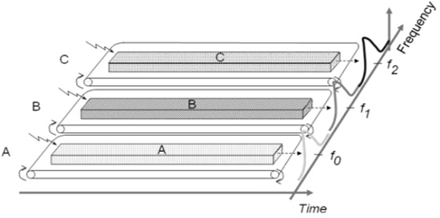  Advantages of FDMA  - As FDMA systems use low bit rates (large symbol time) compared to average delay spread, it offers the following advantages −  - Reduces the bit rate information and the use of efficient numerical codes increases the capacity.  - It reduces the cost and lowers the inter symbol interference (ISI)  - Equalization is not necessary.  - An FDMA system can be easily implemented. A system can be configured so that the improvements in terms of speech encoder and bit rate reduction may be easily incorporated.  - Since the transmission is continuous, less number of bits are required for synchronization and framing.  Disadvantages of FDMA  - Although FDMA offers several advantages, it has a few drawbacks as well, which are listed below −  - It does not differ significantly from analog systems; improving the capacity depends on the signal-to-interference reduction, or a signal-to-noise ratio (SNR).  - The maximum flow rate per channel is fixed and small.  - Guard bands lead to a waste of capacity.  - Hardware implies narrowband filters, which cannot be realized in VLSI and therefore increases the cost.  TDMA Overview  Time Division Multiple Access (TDMA) is a complex technology, because it requires an accurate synchronization between the transmitter and the receiver. TDMA is used in digital mobile radio systems. The individual mobile stations cyclically assign a frequency for the exclusive use of a time interval.  In most of the cases, the entire system bandwidth for an interval of time is not assigned to a station. However, the frequency of the system is divided into sub-bands, and TDMA is used for the multiple access in each sub-band. Sub-bands are known as carrier frequencies. The mobile system that uses this technique is referred as the multi-carrier systems.  In the following example, the frequency band has been shared by three users. Each user is assigned definite timeslots to send and receive data. In this example, user ‘B’ sends after user ‘A,’ and user ‘C’ sends thereafter. In this way, the peak power becomes a problem and larger by the burst communication.  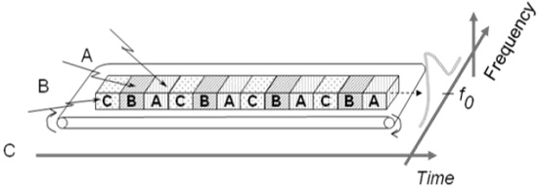  FDMA and TDMA  This is a multi-carrier TDMA system. A 25 MHz frequency range holds 124 single chains (carrier frequencies 200) bandwidth of each kHz; each of these frequency channels contains 8 TDMA conversation channels. Thus, the sequence of timeslots and frequencies assigned to a mobile station is the physical channels of a TDMA system. In each timeslot, the mobile station transmits a data packet.  The period of time assigned to a timeslot for a mobile station also determines the number of TDMA channels on a carrier frequency. The period of timeslots are combined in a so-called TDMA frame. TDMA signal transmitted on a carrier frequency usually requires more bandwidth than FDMA signal. Due to the use of multiple times, the gross data rate should be even higher.  Advantages of TDMA  - Here is a list of few notable advantages of TDMA −  - Permits flexible rates (i.e. several slots can be assigned to a user, for example, each time interval translates 32Kbps, a user is assigned two 64 Kbps slots per frame).  - Can withstand gusty or variable bit rate traffic. Number of slots allocated to a user can be changed frame by frame (for example, two slots in the frame 1, three slots in the frame 2, one slot in the frame 3, frame 0 of the notches 4, etc.).  - No guard band required for the wideband system.  - No narrowband filter required for the wideband system.  Disadvantages of TDMA  - The disadvantages of TDMA are as follow −  - High data rates of broadband systems require complex equalization.  - Due to the burst mode, a large number of additional bits are required for synchronization and supervision.  - Call time is needed in each slot to accommodate time to inaccuracies (due to clock instability).  - Electronics operating at high bit rates increase energy consumption.  - Complex signal processing is required to synchronize within short slots.  Describe Code division multiple Access in detail with neat sketch  CDMA Overview  Code Division Multiple Access system is very different from time and frequency multiplexing. In this system, a user has access to the whole bandwidth for the entire duration. The basic principle is that different CDMA codes are used to distinguish among the different users.  Techniques generally used are direct sequence spread spectrum modulation (DS-CDMA), frequency hopping or mixed CDMA detection (JDCDMA). Here, a signal is generated which extends over a wide bandwidth. A code called spreading code is used to perform this action. Using a group of codes, which are orthogonal to each other, it is possible to select a signal with a given code in the presence of many other signals with different orthogonal codes.  How Does CDMA Work?  CDMA allows up to 61 concurrent users in a 1.2288 MHz channel by processing each voice packet with two PN codes. There are 64 Walsh codes available to differentiate between calls and theoretical limits. Operational limits and quality issues will reduce the maximum number of calls somewhat lower than this value.  In fact, many different "signals" baseband with different spreading codes can be modulated on the same carrier to allow many different users to be supported. Using different orthogonal codes, interference between the signals is minimal. Conversely, when signals are received from several mobile stations, the base station is capable of isolating each as they have different orthogonal spreading codes.  The following figure shows the technicality of the CDMA system. During the propagation, we mixed the signals of all users, but by that you use the same code as the code that was used at the time of sending the receiving side. You can take out only the signal of each user.  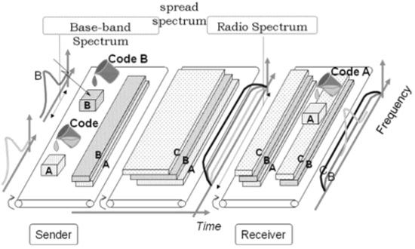 CDMA Capacity  The factors deciding the CDMA capacity are −  Processing Gain  Signal to Noise Ratio  Voice Activity Factor  Frequency Reuse Efficiency  Capacity in CDMA is soft, CDMA has all users on each frequency and users are separated by code. This means, CDMA operates in the presence of noise and interference.  In addition, neighboring cells use the same frequencies, which means no re-use. So, CDMA capacity calculations should be very simple. No code channel in a cell, multiplied by no cell. But it is not that simple. Although not available code channels are 64, it may not be possible to use a single time, since the CDMA frequency is the same.  Centralized Methods  The band used in CDMA is 824 MHz to 894 MHz (50 MHz + 20 MHz separation).  Frequency channel is divided into code channels.  1.25 MHz of FDMA channel is divided into 64 code channels.  Processing Gain  CDMA is a spread spectrum technique. Each data bit is spread by a code sequence. This means, energy per bit is also increased. This means that we get a gain of this.  P (gain) = 10log (W/R)  W is Spread Rate  R is Data Rate  For CDMA P (gain) = 10 log (1228800/9600) = 21dB  This is a gain factor and the actual data propagation rate. On an average, a typical transmission condition requires a signal to the noise ratio of 7 dB for the adequate quality of voice.  Translated into a ratio, signal must be five times stronger than noise.  Actual processing gain = P (gain) - SNR  = 21 – 7 = 14dB  CDMA uses variable rate coder  The Voice Activity Factor of 0.4 is considered = -4dB.  Hence, CDMA has 100% frequency reuse. Use of same frequency in surrounding cells causes some additional interference.  In CDMA frequency, reuse efficiency is 0.67 (70% eff.) = -1.73dB  Advantages of CDMA  CDMA has a soft capacity. The greater the number of codes, the more the number of users. It has the following advantages −  CDMA requires a tight power control, as it suffers from near-far effect. In other words, a user near the base station transmitting with the same power will drown the signal latter. All signals must have more or less equal power at the receiver  Rake receivers can be used to improve signal reception. Delayed versions of time (a chip or later) of the signal (multipath signals) can be collected and used to make decisions at the bit level.  Flexible transfer may be used. Mobile base stations can switch without changing operator. Two base stations receive mobile signal and the mobile receives signals from the two base stations.  Transmission Burst − reduces interference.  Disadvantages of CDMA  The disadvantages of using CDMA are as follows −  The code length must be carefully selected. A large code length can induce delay or may cause interference.  Time synchronization is required.  Gradual transfer increases the use of radio resources and may reduce capacity.  As the sum of the power received and transmitted from a base station needs constant tight power control. This can result in several handovers. | 15 | 2 | 2 | 3 | 1.6.1
12 a  12 b | Illustrate GSM System Architecture, elements and interfaces in detail  A GSM network comprises of many functional units. These functions and interfaces are explained in this chapter. The GSM network can be broadly divided into −  - The Mobile Station (MS)  - The Base Station Subsystem (BSS)  - The Network Switching Subsystem (NSS)  - The Operation Support Subsystem (OSS)  GSM - The Mobile Station  The MS consists of the physical equipment, such as the radio transceiver, display and digital signal processors, and the SIM card. It provides the air interface to the user in GSM networks. As such, other services are also provided, which include −  - Voice teleservices  - Data bearer services  - The features' supplementary services  MS Functions  The MS also provides the receptor for SMS messages, enabling the user to toggle between the voice and data use. Moreover, the mobile facilitates access to voice messaging systems. The MS also provides access to the various data services available in a GSM network. These data services include −  - X.25 packet switching through a synchronous or asynchronous dial-up connection to the PAD at speeds typically at 9.6 Kbps.  - General Packet Radio Services (GPRSs) using either an X.25 or IP based data transfer method at the speed up to 115 Kbps.  - High speed, circuit switched data at speeds up to 64 Kbps.  - We will discuss more about GMS services in GSM - User Services.  What is SIM?  The SIM provides personal mobility so that the user can have access to all subscribed services irrespective of both the location of the terminal and the use of a specific terminal. You need to insert the SIM card into another GSM cellular phone to receive calls at that phone, make calls from that phone, or receive other subscribed services.  GSM - The Base Station Subsystem (BSS)  The BSS is composed of two parts −  - The Base Transceiver Station (BTS)  - The Base Station Controller (BSC)  The BTS and the BSC communicate across the specified Abis interface, enabling operations between components that are made by different suppliers. The radio components of a BSS may consist of four to seven or nine cells. A BSS may have one or more base stations. The BSS uses the Abis interface between the BTS and the BSC. A separate high-speed line (T1 or E1) is then connected from the BSS to the Mobile MSC.  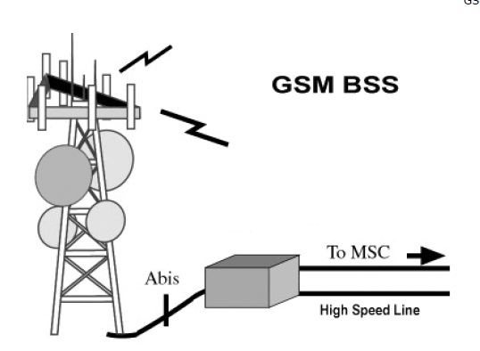The Base Transceiver Station (BTS)  The BTS houses the radio transceivers that define a cell and handles the radio link protocols with the MS. In a large urban area, a large number of BTSs may be deployed.  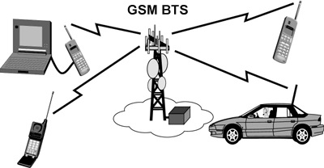  Base Transceiver Station  The BTS corresponds to the transceivers and antennas used in each cell of the network. A BTS is usually placed in the center of a cell. Its transmitting power defines the size of a cell. Each BTS has between 1 and 16 transceivers, depending on the density of users in the cell. Each BTS serves as a single cell. It also includes the following functions −  Encoding, encrypting, multiplexing, modulating, and feeding the RF signals to the antenna  - Transcoding and rate adaptation  - Time and frequency synchronizing  - Voice through full- or half-rate services  - Decoding, decrypting, and equalizing received signals  - Random access detection  - Timing advances  - Uplink channel measurements  The Base Station Controller (BSC)  The BSC manages the radio resources for one or more BTSs. It handles radio channel setup, frequency hopping, and handovers. The BSC is the connection between the mobile and the MSC. The BSC also translates the 13 Kbps voice channel used over the radio link to the standard 64 Kbps channel used by the Public Switched Telephone Network (PSDN) or ISDN.  It assigns and releases frequencies and time slots for the MS. The BSC also handles intercell handover. It controls the power transmission of the BSS and MS in its area. The function of the BSC is to allocate the necessary time slots between the BTS and the MSC. It is a switching device that handles the radio resources.  The additional functions include−  - Control of frequency hopping  - Performing traffic concentration to reduce the number of lines from the MSC  - Providing an interface to the Operations and Maintenance Center for the BSS  - Reallocation of frequencies among BTSs  - Time and frequency synchronization  - Power management  - Time-delay measurements of received signals from the MS  GSM - The Network Switching Subsystem (NSS)  The Network switching system (NSS), the main part of which is the Mobile Switching Center (MSC), performs the switching of calls between the mobile and other fixed or mobile network users, as well as the management of mobile services such as authentication.  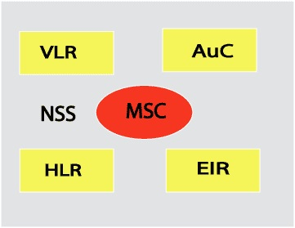The switching system includes the following functional elements −  Home Location Register (HLR)  The HLR is a database used for storage and management of subscriptions. The HLR is considered the most important database, as it stores permanent data about subscribers, including a subscriber's service profile, location information, and activity status. When an individual buys a subscription in the form of SIM, then all the information about this subscription is registered in the HLR of that operator.  Mobile Services Switching Center (MSC)  The central component of the Network Subsystem is the MSC. The MSC performs the switching of calls between the mobile and other fixed or mobile network users, as well as the management of mobile services such as registration, authentication, location updating, handovers, and call routing to a roaming subscriber. It also performs such functions as toll ticketing, network interfacing, common channel signaling, and others. Every MSC is identified by a unique ID.  Visitor Location Register (VLR)  The VLR is a database that contains temporary information about subscribers that is needed by the MSC in order to service visiting subscribers. The VLR is always integrated with the MSC. When a mobile station roams into a new MSC area, the VLR connected to that MSC will request data about the mobile station from the HLR. Later, if the mobile station makes a call, the VLR will have the information needed for call setup without having to interrogate the HLR each time.  Authentication Center (AUC)  The Authentication Center is a protected database that stores a copy of the secret key stored in each subscriber's SIM card, which is used for authentication and ciphering of the radio channel. The AUC protects network operators from different types of fraud found in today's cellular world.  Equipment Identity Register (EIR)  The Equipment Identity Register (EIR) is a database that contains a list of all valid mobile equipment on the network, where its International Mobile Equipment Identity (IMEI) identifies each MS. An IMEI is marked as invalid if it has been reported stolen or is not type approved.  GSM - The Operation Support Subsystem (OSS)  The operations and maintenance center (OMC) is connected to all equipment in the switching system and to the BSC. The implementation of OMC is called the operation and support system (OSS).  Here are some of the OMC functions−  - Administration and commercial operation (subscription, end terminals, charging, and statistics).  - Security Management.  - Network configuration, Operation, and Performance Management.  - Maintenance Tasks.  The operation and Maintenance functions are based on the concepts of the Telecommunication Management Network (TMN), which is standardized in the ITU-T series M.30.  Following is the figure, which shows how OMC system covers all the GSM elements.  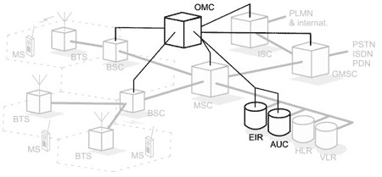The OSS is the functional entity from which the network operator monitors and controls the system. The purpose of OSS is to offer the customer cost-effective support for centralized, regional, and local operational and maintenance activities that are required for a GSM network. An important function of OSS is to provide a network overview and support the maintenance activities of different operation and maintenance organizations.  A simple pictorial view of the GSM architecture is given below  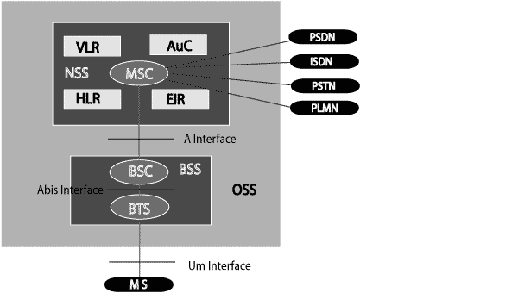  GSM Architecture  The additional components of the GSM architecture comprise of databases and messaging systems functions −  - Home Location Register (HLR)  - Visitor Location Register (VLR)  - Equipment Identity Register (EIR)  - Authentication Center (AuC)  - SMS Serving Center (SMS SC)  - Gateway MSC (GMSC)  - Chargeback Center (CBC)  - Transcoder and Adaptation Unit (TRAU)  The following diagram shows the GSM network along with the added elements −  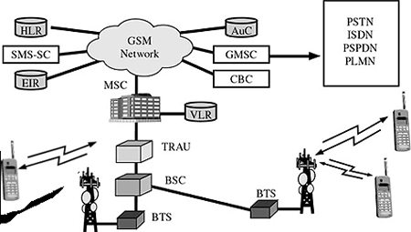The MS and the BSS communicate across the Um interface. It is also known as the air interface or the radio link. The BSS communicates with the Network Service Switching (NSS) center across the A interface.  GSM network areas  In a GSM network, the following areas are defined −  Cell − Cell is the basic service area; one BTS covers one cell. Each cell is given a Cell Global Identity (CGI), a number that uniquely identifies the cell.  Location Area − A group of cells form a Location Area (LA). This is the area that is paged when a subscriber gets an incoming call. Each LA is assigned a Location Area Identity (LAI). Each LA is served by one or more BSCs.  MSC/VLR Service Area − The area covered by one MSC is called the MSC/VLR service area.  PLMN − The area covered by one network operator is called the Public Land Mobile Network (PLMN). A PLMN can contain one or more MSCs.  Explain 4G Cellular Systems with its types in details  The Fourth Generation (4G) of broadband cellular network technology is based on the capabilities defined by the ITU(International Telecommunication Union) in IMT Advanced (International Mobile Telecommunications Advanced) which supersede the 3G. It is popularly referred to as MAGIC, which is the acronym for “Mobile multimedia, Any-where, Global mobility solutions over, Integrated wireless and Customized services.” According to the ITU, a 4G network requires a mobile device to be able to exchange data at 100 Mbps for high mobility communication and 1 Gbps for low mobility communication. Potential and current applications include amended mobile web access, IP telephony, gaming services, high-definition mobile TV, video conferencing, 3D television.  4G is much faster than 3G, and this has revolutionised the field of telecommunication by bringing the wireless experience to a new level altogether. 4G systems support interactive multimedia, voice, video, wireless internet and other broadband services. Technologically, 4G is very different compared to 3G.  When was 4G introduced?  - The fourth generation of mobile technology was introduced in 2010 in order to meet out the need for faster speed and better connectivity.  - Airtel was the first company to have launched 4G services using TD-LTE technology in Kolkata in 2012. It was followed by the launch of 4G in Bangalore, Pune, Chandigarh, Mohali and Panchkula.  - Later, 4G services in India was launched by Aircel, Vodafone and RJIO.  What are the features of 4g?  The features of 4G are :  - Better download speed  - Extremely high voice quality.  - Easy access to Internet, IM, social networks, streaming media, video calling.  - Higher bandwidth.  - Much faster than 3G  What are the different Network Standards of 4G?  There are multiple 4G mobile technology standards used by different cellular providers that conform to 4G requirements, namely,  - LTE (pre – 4G),  - LTE-Advanced,  - WiMAX, and  - Ultra Mobile Broadband (UMB).  Note – LTE stands for Long Term Evolution (LTE).  How are mobile communication technologies classified?  Based on the architecture of the mobile network, mobile communication technologies are classified into different generations identified as 1G, 2G, 3G, 4G, and 5G. The architecture of the mobile network has rapidly evolved over the last few decades.  - The First Generation or 1G  - The first generation (1G) mobile network system came around 1982.  - It was used to transmit only voice calls.  - The analog signals were used to carry voices between the caller and receiver.  - The Second Generation or 2G  - The second generation (2G) mobile network system came around 1991.  - Instead of analog signals, voice calls were transmitted in digital form, thus providing improved call quality.  - This increased capacity allowed more people to talk simultaneously and led to improved security as the signals could be encrypted. It also enabled an additional service to send SMS and MMS (Multimedia messages).  - The Third Generation or 3G  - The third generation (3G) mobile network technology was developed during the late 90s, but it was introduced commercially around 2001.  - It offered both digital voice and data services.  - 3G provided Internet access via the same radio towers that provide voice service to the mobile phone.  - It facilitated greater voice and data capacity.  - Therefore, more simultaneous calls could happen in the same frequency range and also a significantly faster data transfer speed.  What is the difference between 4g and 5g?  The major differences between the 4G and 5G networks are listed below:  - 5G network provides enhanced network coverage compared to the 4G.  - Data bandwidth of 5g is above 1gbps, whereas for 4G it lies between 2mbps to 1gbps.  - The latency of the 5G network is smaller compared to 4G.  What are the advantages of the 5g network?  - 5G network will allow faster uploading and downloading.  - The high data speed of the 5G Network would work in favour of cloud systems to enhance software updates, music, and navigation.  - The Fifth Generation or 5G is expected to be a milestone development for the success of IoT and Machine to Machine (M2M)  communications. Machine to machine (M2M) is direct communication between devices — wired and wireless.  - 5G is expected to allow data transfer in Gbps, which is much faster than 4G. It is expected to be able to support  all the devices of the future, such as connected vehicles and the Internet of Things. | 15 | 3 | 3 | 3 | 1.6.1

*Performance Indicators are available separately for Computer Science and Engineering in AICTE examination reforms policy.

Course Outcome (CO) and Bloom’s level (BL) Coverage in Questions

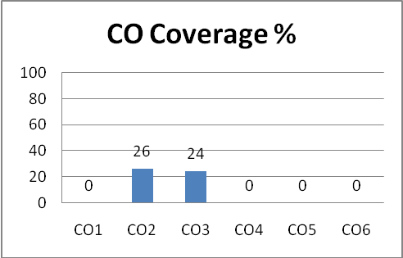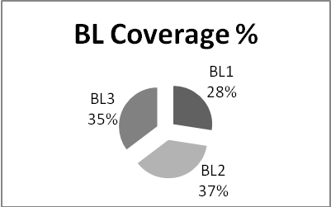

Approved by the Audit Professor/Course Coordinator

